 | Abdi İpekçi Caddesi Kaşıkçıoğlu Apt. No:42 D:2  34365, Nişantaşı, İstanbul  www.artxist.com - info@artxist.com  T. +90 212 291 77 84 F. +90 212 343 69 35 | PRESS RELEASE

THE OTHER KEMAL | AHMET POLAT

“As much as I had hoped to discover a truth about life, I’m left with a medium that in a whole is running away from the truth and instead it’s burying it underneath layers and layers of images.” (Ahmet Polat)

x-ist hosts Ahmet Polat’s new photography show “The Other Kemal” between March 6 – 29, 2014. Ahmet Polat previously had two solo shows at x-ist, “Submitting to Change” (2005) and “Invitations Only” (2006), followed by several international shows in Netherlands, Austria and Brazil. After a short break, Polat finally returns to the Turkish art scene with “The Other Kemal”.

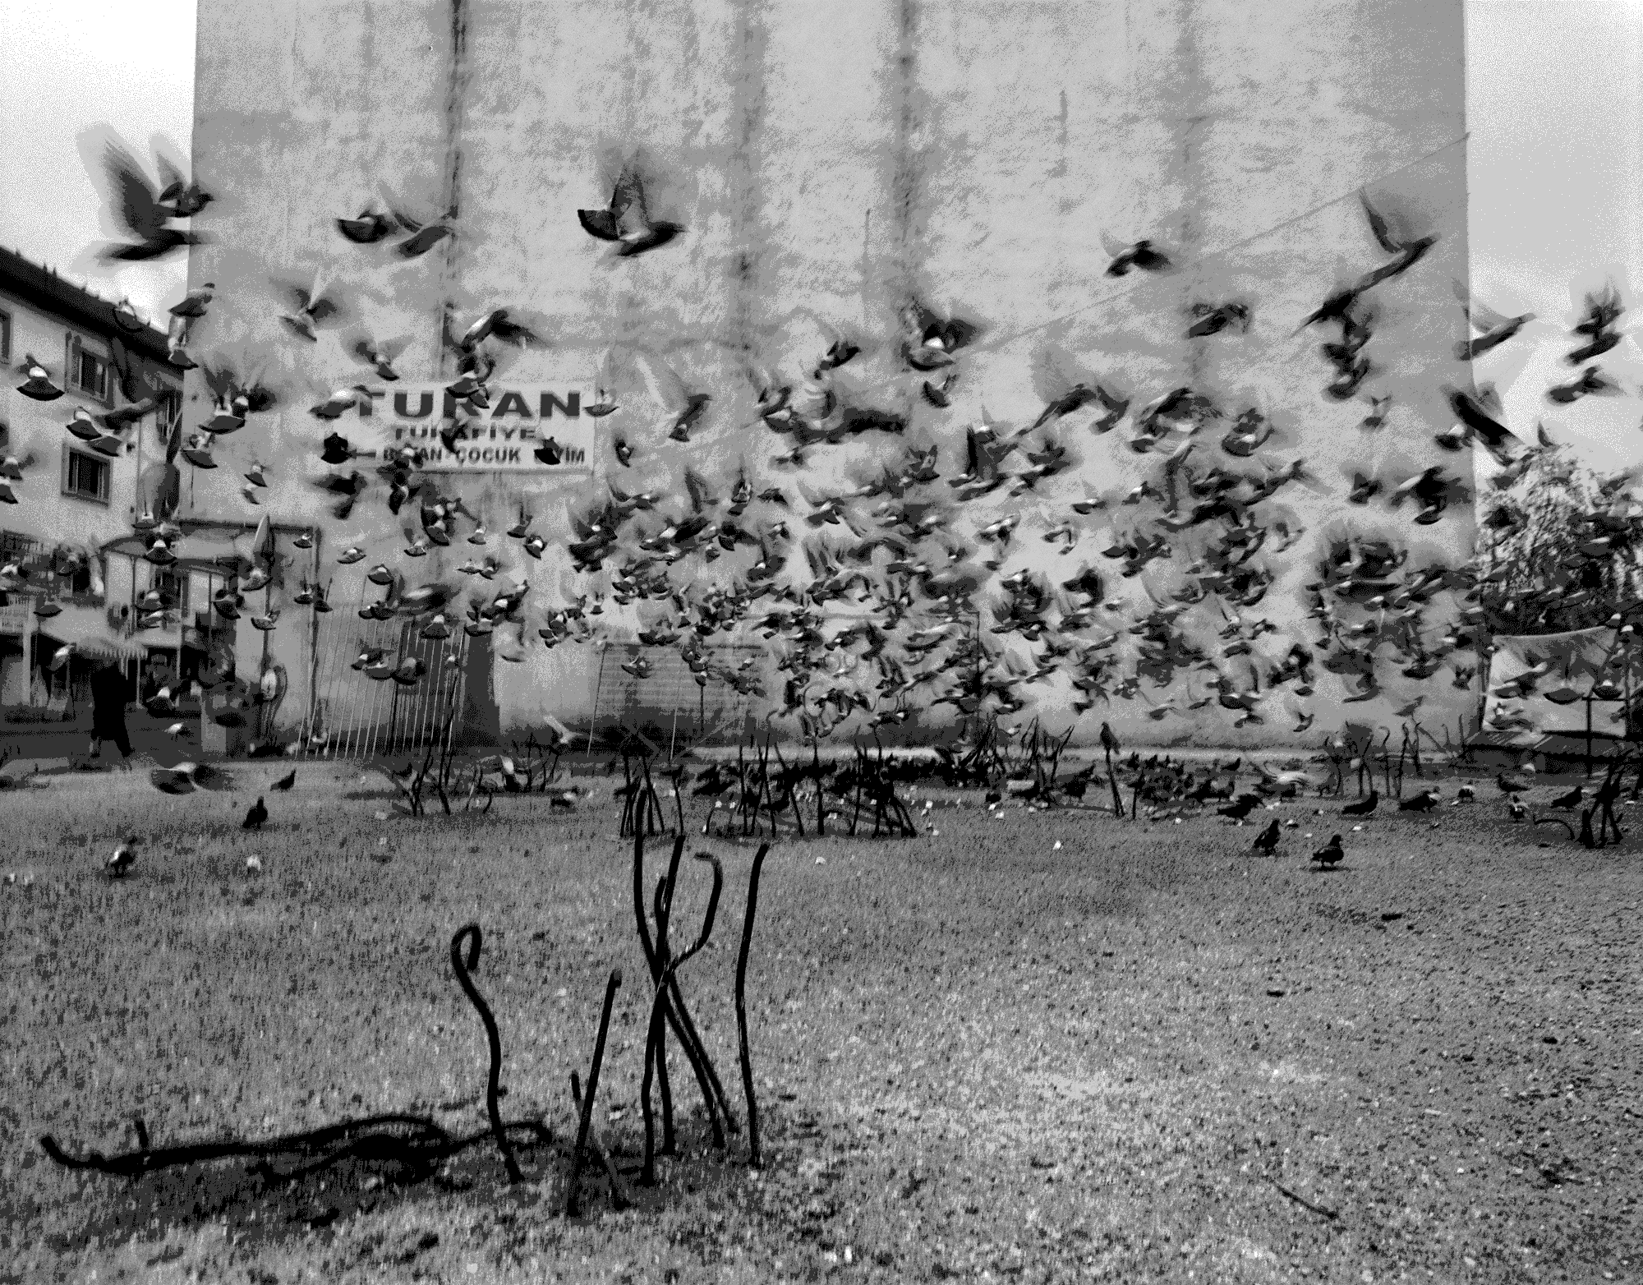

Ahmet Polat, "The Other Kemal Serisi – Birds” (Kocaeli, Turkey, 2008), Photography

Ahmet Polat created Kemal’s Dream, one of the most important series of his career, between 2006-2012, travelling from Istanbul to the Black Sea and from Gaziantep in the south-east to the Aegean region, photographing and interviewing the Turkish youth. After this series he took the time to reflect more on his work and for this show, selected a group of images from Kemal’s Dream that have never shown before in addition to some earlier work which have played a crucial role in the discovery of his new look on photography. With “The Other Kemal”, Ahmet Polat rethinks his relationship with photography and its power to represent or manipulate the truth. Bringing out the collisions in the society through details of everyday life, the artist, this time, is not interested in what the images show, but what they actually disguise. Thus, he re-evaluates his initial goals to set out on this journey in Turkey and their outcome, basically questioning his choice to use photography as a medium.

“Like in the David Lynch’s movie Dune, where Paul Atreides, potrayed by actor Kyle MacLachlan, is in a fighting scene where he learns that only a slow blade can penetrate the protective energy shield of his opponent whilst the hard and fast blade just gets rejected. Photography is exactly the same, it’s like a slow blade with which you can peel of the protective shields that people try to keep up.” (Ahmet Polat)

Ahmet Polat seeks the interplay between expectations, prejudices and affirmation and offers alternative interpretations of the prevalent problems and the relationship between Turkey’s past and future both through the content and the presentation of his work. Due to his upbringing of a Dutch mother and Turkish father, he has integrated both perspectives of the outsider and insider, encouraging the viewer to find links between personal and social scenes.

Ahmet Polat looks beyond the masks that people and societies put forth and the problematics of photography during this journey, in his new show “The Other Kemal” which can be seen at x-ist until March 29th.

AHMET POLAT | Netherlands, 1978

Ahmet Polat is a Dutch-Turkish photographer living in İstanbul. After graduating from St. Joost Academy in Breda he had many solo exhibitions in Turkey and Netherlands. In his work he upbrings the fusion of West and East. Among his solo exhibitions are “After the Quake” (Zuidplein Theatre, Rotterdam, 1999), “Silence in Kayapinar” (Dordrechts Museum, Netherlands, 2001), “Home Is Where I Left My Dreams” (Karşı Sanat Gallery, İstanbul, 2003), “Old Country, New Country” (Photo Museum, The Hague, 2004), “Home Is Where I Left My Dreams” (Resim Heykel Museum, Ankara, Turkey and KunstKerk, Dordrecht, Netherlands, 2004), “Who Are You?” (Istanbul Modern Museum, Istanbul, 2007), “Neither Here nor There” (NBKS during the Breda Photo Biennial, 2008 and FotoPub Festival, Slovenia, 2009), “Kemal's Dream” (FOAM, Amsterdam, 2010), “Dark Moon” (LhGWR, The Hague, 2011 and Cezayir, Istanbul, 2012), “Kemal’s Dream” (DEPO, Istanbul, 2012). At x-ist he had two solo shows “Submitted to Change” (2005) and “Invitation Only” (2006) and a public space installation “Where Are You?” in 2007. Polat has received the “Young Photographer” award in the 22nd Infinity Awards given by one of the most important photography institutions of the world, ICP (International Center of Photography). The artist also participated in the group shows titled “Month of Photography” (Lokaal 01, Breda, 2003), “Small Works X” (Gallery R.A.M., Rotterdam, 2004), “The Bison Caravan” (The Water Tower, Vlissingen, 2004), “Travel” (Gallery R.A.M., Rotterdam, 2004), “Old Country, New Country” (Stroom, The Hague, 2005), “Genç Açılım” (Pera Museum, Istanbul, 2005), “Different Dimensions” (Gallery R.A.M., Rotterdam, 2005), “De zilveren Camera” (Photo Museum, The Hague, 2007), “Collection of Hans Kemna” (De Hallen, Haarlem,2008), “Fluorescent Adolescent” (7th International Biennial of Photography, Glaspaleis, Heerlen, 2010), “In what language shall I tell you my story?” (Stedelijk Schiedam, 2012), “Istanbul Modern – Bahrain” (Bahrain National Museum, 2013). Polat also took commercial and fashion photographs for several international magazines such as French and Turkish Vogue, Paris Match, Marie Claire, Quest and Vice. Among the art fairs Polat participated are Art-Rotterdam, Contemporary Istanbul 07, 12 & 13, UNSEEN Amsterdam 2012 and ArtInternational Istanbul 13. The book of his latest work “Kemal’s Dream” has been launched in the Unseen Photography Fair, Amsterdam in 2012. In 2013, Polat was nominated for the long list of Dutch Doc Award, the largest Dutch photography prize, with his two different projects, “Kemal’s Dream” and “Dark Moon”.

For more information please contact Ece Göymen from gallery x-ist.
ece@artxist.com
M. +90 537 349 13 27
T. +90 212 291 77 84

